**THE PALM VALLEY**

**NEWSLETTER**

Message from the Mayor

Citizens of Palm Valley,

Another election is past us and I am very excited to announce that Councilwoman Julie Martin was re-elected and kept her seat on the Council. In addition, newcomer Paul Powers was elected to his first term as our city’s fifth Councilmember. Congratulations to both of you!

I also want to thank all of you that voted for the Sales Tax Proposition. This is a great start for our city. With this extra boost to our budget, we will start building a fund for the purpose of upgrading our infrastructure.

As I am extremely overjoyed by the results of our election, I am equally saddened to see long term Councilmember Joe Jones leave us. Joe dedicated 4 years as your Councilman. We owe him a tremendous debt of gratitude. I, for one, will miss Joe sitting next to me. I wish him well on his retirement.

As I mentioned, I am very excited with the election results. Our City Council and I are ready to roll up our sleeves and get started in making Palm Valley the most attractive City in South Texas.

George R Rivera

Mayor

World War II Veterans

Every year on Memorial Day we pause and honor the sacrifices, courage, and patriotism of all the men and women who have served our country in the military. This year’s holiday, I was fortunate enough to meet the national board members of ForeverYoung Senior Veterans Organization. ForeverYoung is a wish-granting organization that brings Honor, Healing, and Hope to military veterans 65 years and older by granting their unfulfilled dreams.

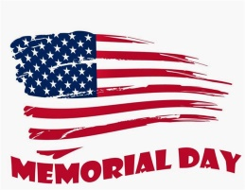I have been personally asked by the Board if I can provide a veteran/member of our community to represent the City of Palm Valley for a “Mission”. ForeverYoung is currently looking for WWII Vets that served in Europe or in the Pacific. If you, or someone you know, resides in Palm Valley and was in Europe and/or the Pacific during WWII, please let me know. I will be honored to nominate you to this “Special Mission”.

George R. Rivera

Mayor

Air Force Veteran, 1979-1986

Oaths of Office

The below individuals were administered their Oaths of Office at the Council meeting of May 15, 2017.

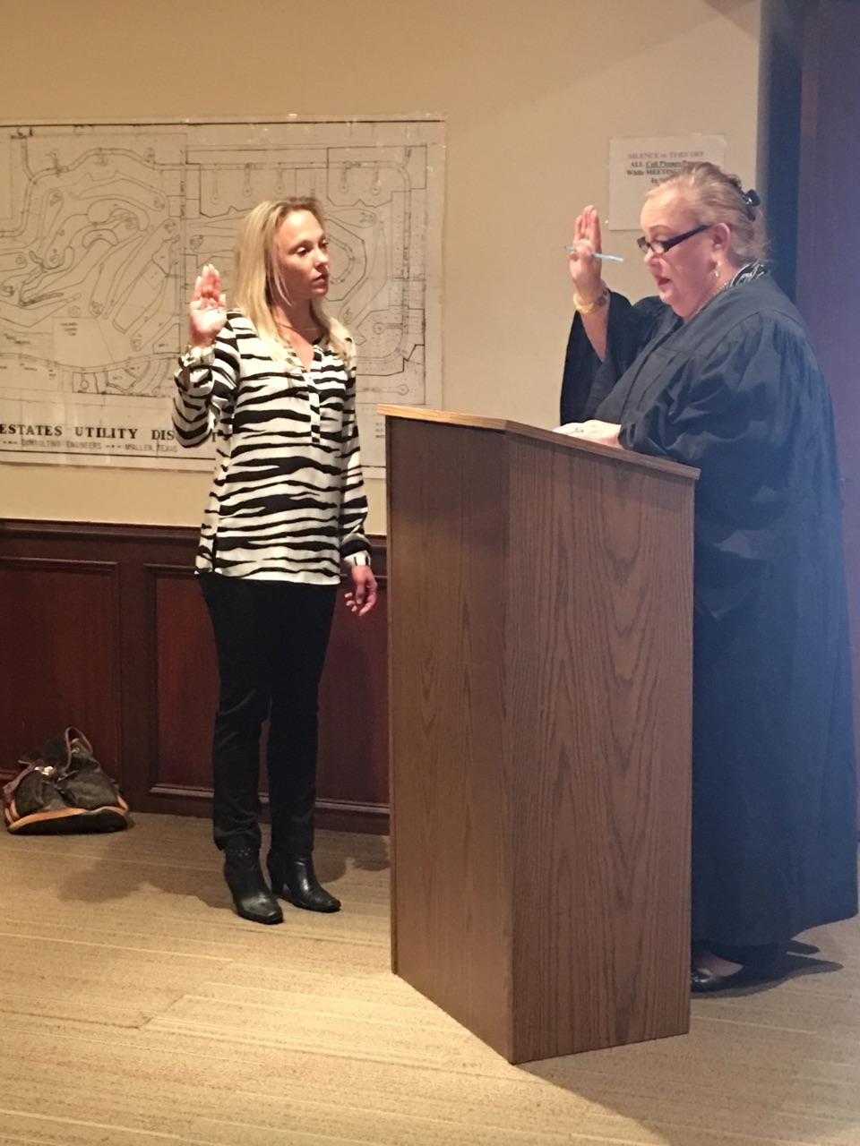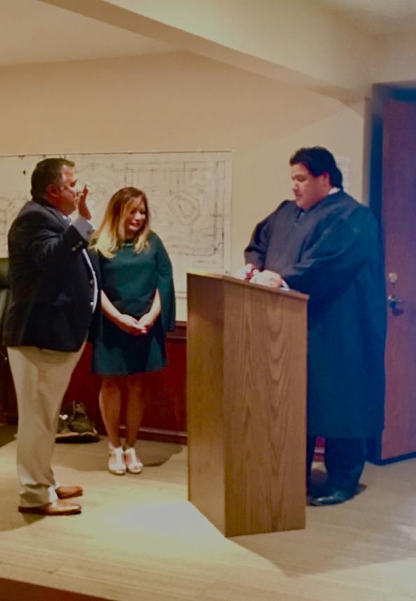

Councilwoman Julie Martin was sworn in by Judge Sallie Gonzalez to serve another 2-year term.

Mayor George Rivera was sworn in by Judge David Sanchez to serve another 2-year term.

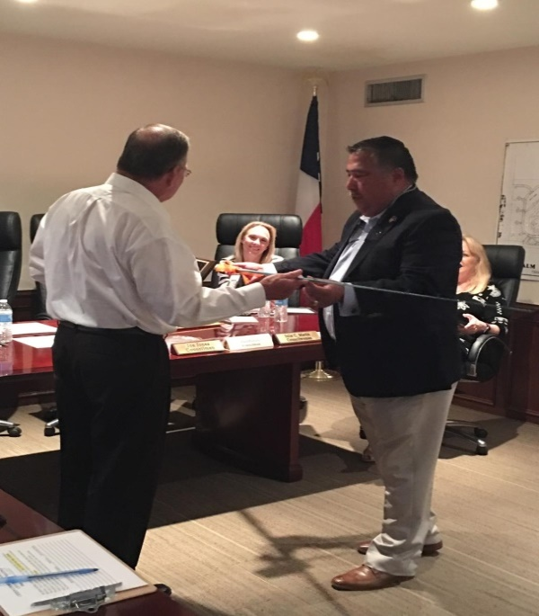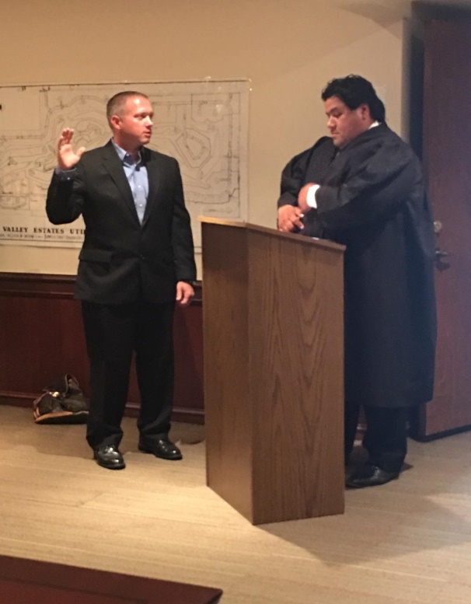

Mayor Rivera presented a special gift to Councilman Joe Jones for his service and dedication to the City Council for 4 years. Mr. Jones was presented a “top of the line” fishing pole as he will now have more fun time available. Mr. Jones was also presented with a plaque of appreciation.

Councilman Paul Powers was sworn in by Judge David Sanchez to serve his first term on the Council.

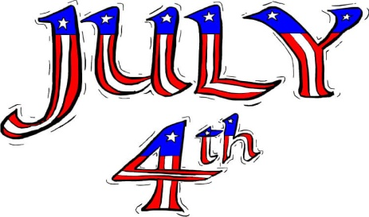

**Message from Parks and Recreations Board**

**Fourth of July Parade 2017**

Citizens of Palm Valley,

The Parks and Recreation Board is planning and putting together another great parade. This year’s parade promises to be bigger and better, if that could be possible!

The classic cars, the horses and, of course, the decorated golf carts are all back this year. This is a truly City event and we invite all to participate.

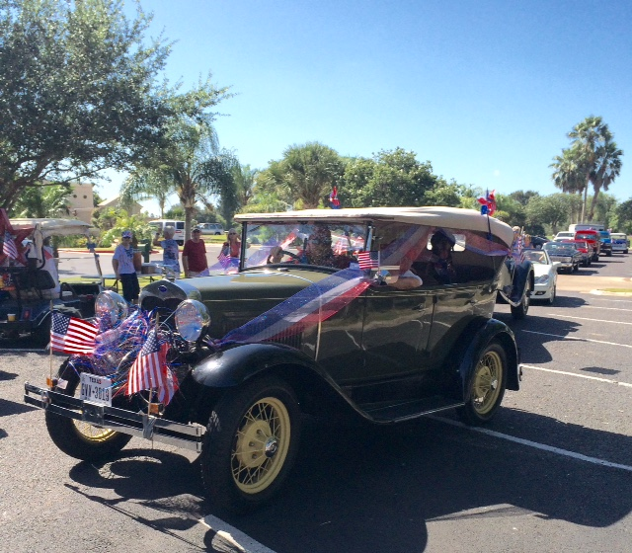If you have or know of a group that wants to participate in this year’s parade please contact the City.

Looking forward to seeing all there,

Parks and Recreation Board

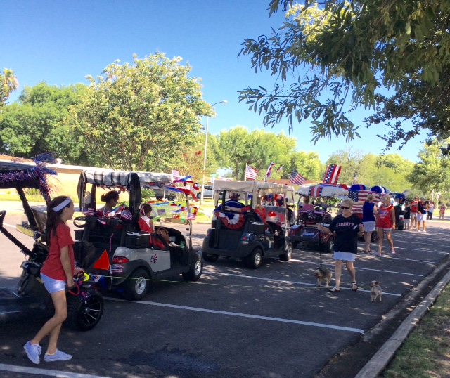

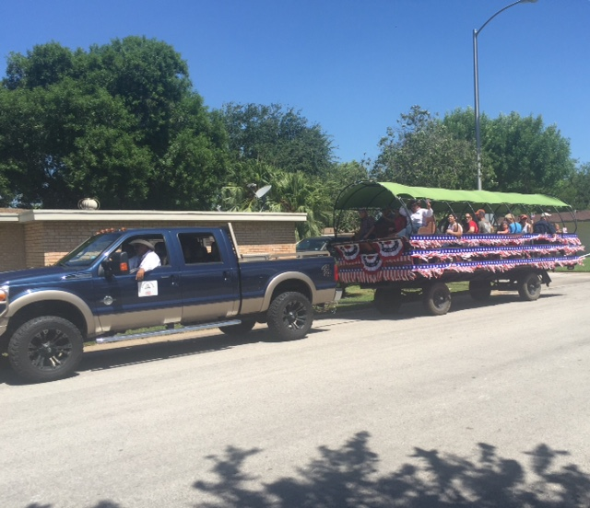

**Message from Chief A. Garcia**

Summer is upon us, we urge all of our residents to keep alert of

* Walkers
* Joggers
* Bicyclists
* Children playing outdoors

Please remember to use reflective gear while

performing any activities outdoors after dark.

Report any suspicious activity to 873-1500.

**Message from Water Department**

**MOSQUITOS**

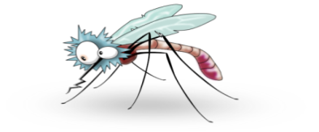These pesky insects are still numerous due to continued rain. We ask that all residents help us reduce the mosquito population.

These are some of the things you can do for mosquito control:

* Get rid of old tires, tin cans, buckets, drums, bottles or any water holding containers.
* Fill in or drain any low places (puddles, ruts) in yard.
* Keep drains, ditches and culverts clean of weeds and trash so water will drain properly.
* Cover trash containers to keep out rainwater.
* Repair leaky pipes and outside faucets.
* Empty plastic wading pool at least once a week and store it indoors when not in use.
* Fill in tree rot holes and hollow stumps that hold water with sand or concrete.
* Change the water in birdbaths and plant pots or drip trays at least once each week.
* Keep grass cut short and shrubbery well-trimmed around the house.
* Apply mosquito control spray using your garden hose.
* Make sure your pool is properly cared for while on vacation.

By working together we can minimize, if not eliminate, the public health threat posed by mosquitoes. Public’s health is everyone’s responsibility.



**UPCOMING DATES TO REMEMBER:**

Hurricane Season June 1, 2017- Nov 30, 2017

Parks & Recreation Board Meeting June 14, 2017 @ 5:30p.m.

Father’s Day June 18, 2017

1st day of Summer June 21, 2017

Kids’ Triathlon @ Harlingen Country Club July 1, 2017 Contact Bicycle World @ 423-3168

Independence Day July 4, 2017

4th of July Parade July 4, 2017 @ 10:30a.m.

The next regular City Council meeting is scheduled for

June 20, 2017 at 6:00p.m.

We invite you to attend.



**THE COUNCIL**

Mayor: George Rivera

Mayor Pro-Term: John Widger

Councilmembers: Julie C. Martin, Cynthia Thompson, Deborah Wright, and Paul Powers.

City Hall: 423-8384

Municipal Court: 423-8384

Police DPT: 873-1500

Water Services: 423-4040

City’s Website: [www.palmvalleytx.com](http://www.palmvalleytx.com)