the palm valley review

St. Patrick’s Day

Every year on March 17, the Irish and the Irish-at-heart across the globe observe St. Patrick’s Day. What began as a religious feast day for the patron saint of Ireland has become an international festival celebrating Irish culture with parades, dancing, special foods and a whole lot of green.

**Message from the Mayor,**

Citizens of Palm Valley can you believe it is election season again. It feels like it was just yesterday that we finished the last election.

This year’s election we have three of our citizens vying for two City Council positions. Incumbent City Councilwoman Julie Martin, Neighborhood Watch Coordinator Charlie Ramsey, and Parks and Recreation Board Member Paul Powers are on the ballot and will be asking for your vote. I wish all three the best of luck.

This year’s Mayor’s race is uncontested; therefore I have the honor of serving our community for two more years.

Also this year is a Special Election. A Proposition, **“The adoption of a local sales and use tax in the City of Palm Valley at the rate of one percent (1%)”** to raise the City’s Sales Tax from 7.25% to 8.25%. Our City Council unanimously approved for this proposition to be added to this year’s ballot. The purpose for this Proposition is to generate additional revenue to create and build a fund for future major repairs our City will need in the years to come.

This year’s election is on May 6, 2017. Early voting begins on April 24, 2017 thru May 2, 2017.

I encourage all Palm Valley citizens to exercise their right to vote. Believe it or not your vote does and will matter!

George R. Rivera

Mayor

City of Palm Valley

**Chief Garcia’s Report PVPD #: (956)873-1500**

**Scams Targeting Taxpayers/IRS-Impersonation Telephone Scams**

An aggressive and sophisticated phone scam targeting taxpayers, including recent immigrants, has been making the rounds throughout the country. Callers claim to be employees of the IRS, but are not. These con artists can sound convincing when they call. They use fake names and bogus IRS identification badge numbers. They may know a lot about their targets, and they usually alter the caller ID to make it look like the IRS is calling.

Victims are told they owe money to the IRS and it must be paid promptly through a pre-loaded debit card or wire transfer. If the victim refuses to cooperate, they are then threatened with arrest, deportation or suspension of a business or driver’s license. In many cases, the caller becomes hostile and insulting. Or, victims may be told they have a refund due to try to trick them into sharing private information. If the phone isn't answered, the scammers often leave an “urgent” callback request.

Note that the IRS will never:

* Call to demand immediate payment using a specific payment method such as a prepaid debit card, gift card or wire transfer. Generally, the IRS will first mail you a bill if you owe any taxes.
* Threaten to immediately bring in local police or other law-enforcement groups to have you arrested for not paying.
* Demand that you pay taxes without giving you the opportunity to question or appeal the amount they say you owe.
* Ask for credit or debit card numbers over the phone.

***Thank you – Alvaro Garcia, Chief of Police***

**Elections 2017**

Deadline to register to vote in the election is April 6, 2017. Voter registration forms are available at the Cameron County Annex building on Wilson Road. You may contact the County Elections Division at (956) 544-0809 for further information or visit the Secretary of State’s website at [www.sos.state.tx.us.](http://www.sos.state.tx.us.)

Note: As per City ordinance, only one political sign per lot per candidate is permitted in the City---maximum size: 2’ x 3’.

**Early Voting by Personal Appearance Schedule (for qualified registered voters of Palm Valley)**



CITY OF PALM VALLEY GENERAL ELECTION

For more information, please call City Hall at (956)423-8384

Para mas informacion, favor llame al City Hall (956)423-8384

Monday April 24, 2017 8:00a.m. – 5:00p.m.

Tuesday April 25, 2017 7:00a.m. – 7:00p.m.

Wednesday April 26, 2017 8:00a.m. – 5:00p.m.

Thursday April 27, 2017 8:00a.m. – 5:00p.m.

Friday April 28, 2017 8:00a.m. – 5:00p.m.

Monday May 1, 2017 7:00a.m. - 5:00p.m.

Tuesday May 2, 2017 8:00a.m. - 5:00p.m.

**Christmas Decoration Winners for the month of December**

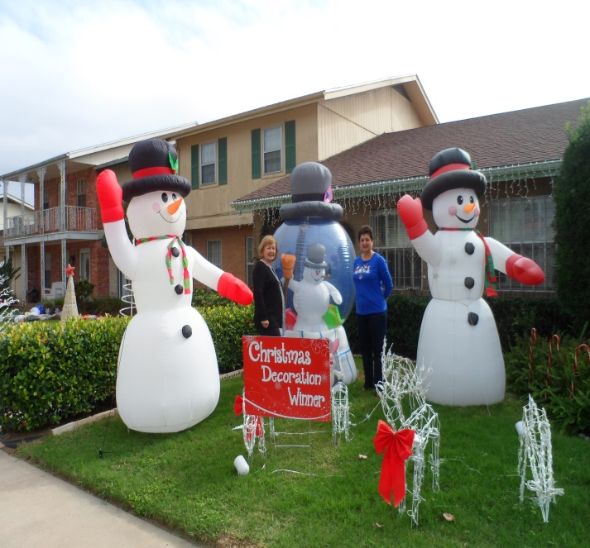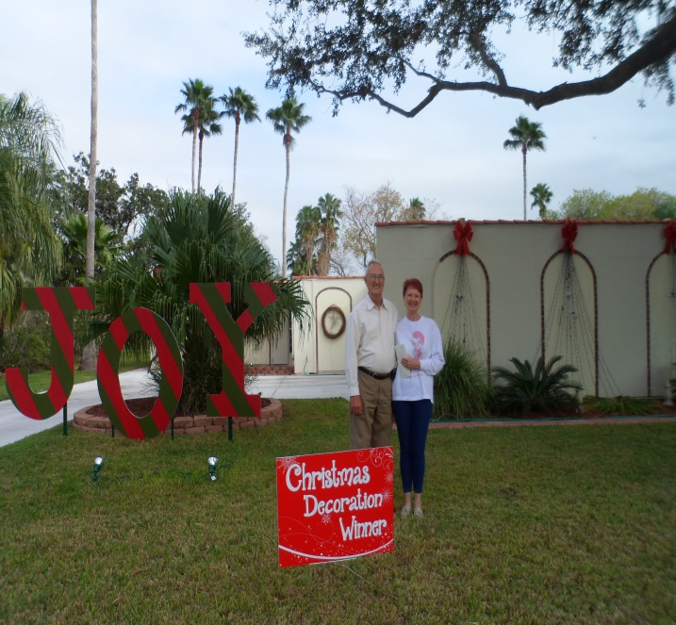

Odette O’Reilly and Espie Whitis Mr. and Mrs. John McGarry

For the entire block of 5501-5522 Brazo Circle 516 Palm Valley Dr West

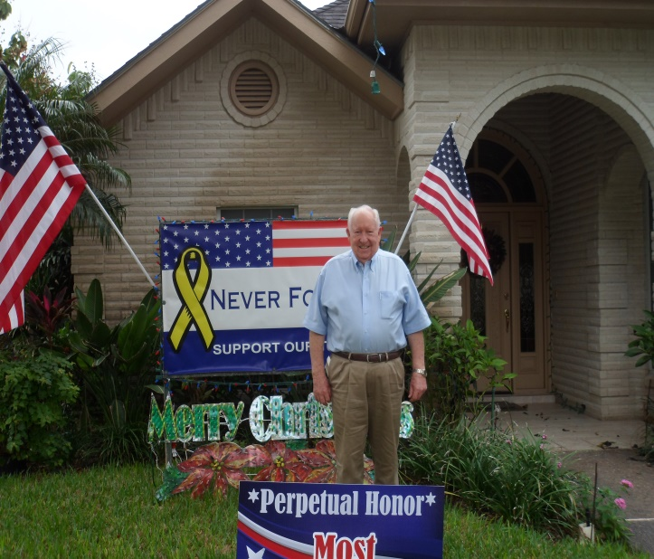

.

Perpetual Honor goes to Best Christmas Decor Commercial goes to

Mr. L.D. Gray Dunkin & Associates

1716 Palm Valley Dr East 1305 N. Stuart Place Rd.

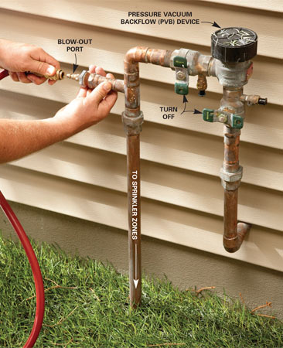

**BACKFLOW WATER PREVENTION**

Many of you have, by now, received letters from City Hall, requiring the installation of backflow preventers on your properties. This is a TCEQ (Texas Commission on Environmental Quality) mandate being enforced through the City ordinance (No. 2011-2). Every resident will be receiving the letter that outlines all of the requirements that must be met. Any questions you might have, please feel free to call the Water Department at (956)423-8384 or if need be, you may also contact the TCEQ local office at (956)425-6010. The City has mailed out approximately 250 letters so far and most of the residents have complied. We thank you for your cooperation.

**FRIENDLY REMINDERS**

Dog Waste stations are located throughout the City for the disposal of your pets’ poop’ - (Chapter 95: Animal Control).

Property Cleanup – (Chapter 90: Health and Sanitation: Nuisances)

Overhanging limbs/branches – (Chapter 90: Health and Sanitation: Nuisances)

Parking on the Street – (Chapter 72: Parking Regulations)

Requiring reflective gear for walkers/joggers/bicyclists – (Chapter 70: General Provisions)

All City ordinances can be found on the City’s website at [www.palmvalleytx.com](http://www.palmvalleytx.com).

**CITY HALL RENOVATIONS**

The next regular City Council meeting is scheduled for March 21, 2017 @ 6pm.

We invite you to attend.

City Hall has recently had a makeover. We invite the public to

stop by and enjoy the updated modern take of City Hall.

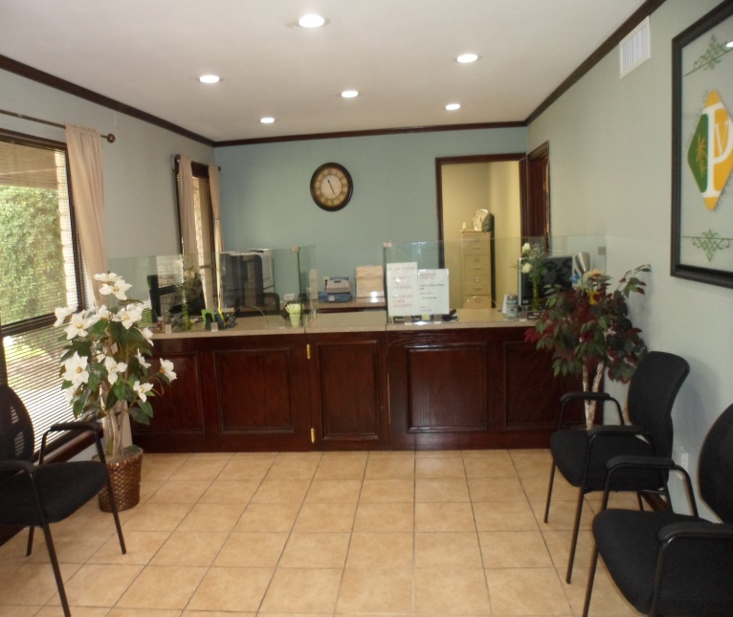

**THE COUNCIL**

Mayor: George Rivera

Mayor Pro-Term: John Widger

Councilmembers: Joe Jones, Julie C. Martin, Cynthia Thompson, and Debe Wright

City Hall 423-8384

Municipal Court 423-8384

Police DPT 873-1500

Water Services 423-4040

City’s Website: [www.palmvalleytx.com](http://www.palmvalleytx.com)

